Indirect Invocation

* myFun.call()
* myFun.apply()

Functions in JavaScript

* first-class objects
  + function is an object
  + type of function object is *Function*

List of methods of a Function object: <https://developer.mozilla.org/en-US/docs/Web/JavaScript/Reference/Global_Objects/Function#Methods>

.call() and .apply()

* used to invoke the function with a CONFIGURABLE context

myFunction.call(thisArg, arg1, arg2, …)

* first argument (thisArg)
  + the context of the invocation
* remaining arguments
  + arguments to be passed in the function itself

myFunction.apply(thisArg, [arg1, arg2, …])

* first argument (thisArg)
  + the context of the invocation
* remaining arguments (array)
  + arguments to be passed in the function itself

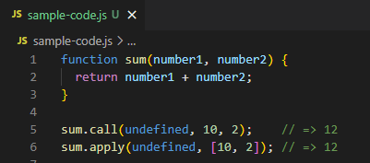

sum.call() and sum.apply() both invoke the function with 10 and 2 arguments